**Insurance Premium Prediction**

***Wireframe Documentation***



***Project On:***

***Title: Insurance Premium Prediction***

***By: - Shobhandeb Paul***

***(iNeuron)***

***Date: - 07/01/2022***

***Landing Page:***

***This is the landing page where the user/policyholder is allowed rather to put inputs on the parameters shown in order to get a rough idea about the premium for a given set of conditions.***

***As soon as the user/policyholder hits the Show Result button, the premium gets displayed based on the conditions given.***

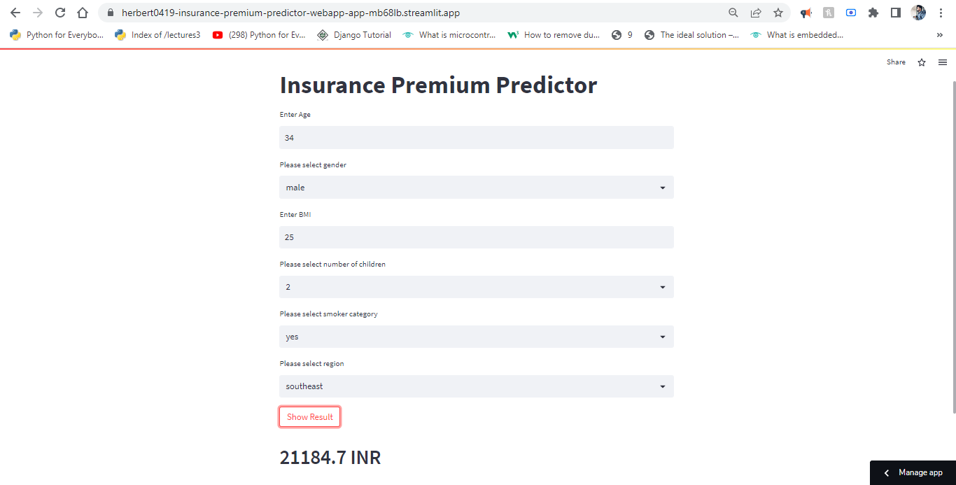

***URL to the app deployed:***

***<https://herbert0419-insurance-premium-predictor-webapp-app-mb68lb.streamlit.app/>***